PROJECT DESIGN PHASE-II

TECHNOLOGY STACK (ARCHITECTURE & STACK)
Date: 26 September 2026
Team ID: SWTID-2026-9625
Project Name: AI FAQ Assistant API
Maximum Marks: 4 Marks
Technical Architecture
The AI FAQ Assistant API is a backend-only REST API architecture. Client requests are sent through Postman or an application client to the Node.js and Express.js application. The request passes through authentication, authorization, validation, sanitization, and rate-limiting middleware before reaching the appropriate controller and service layer. The application uses MongoDB as its database for storing users, FAQs, categories, tags, AI-generated FAQs, and feedback. Google Gemini is used as the external AI service for AI-powered FAQ generation and question answering. The system also provides keyword-based FAQ search across questions, answers, categories, and tags.
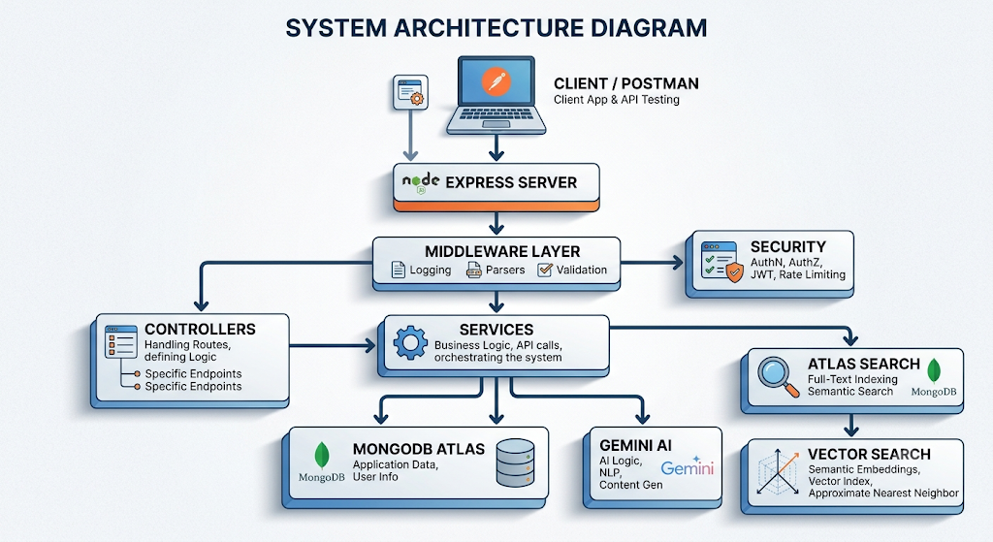
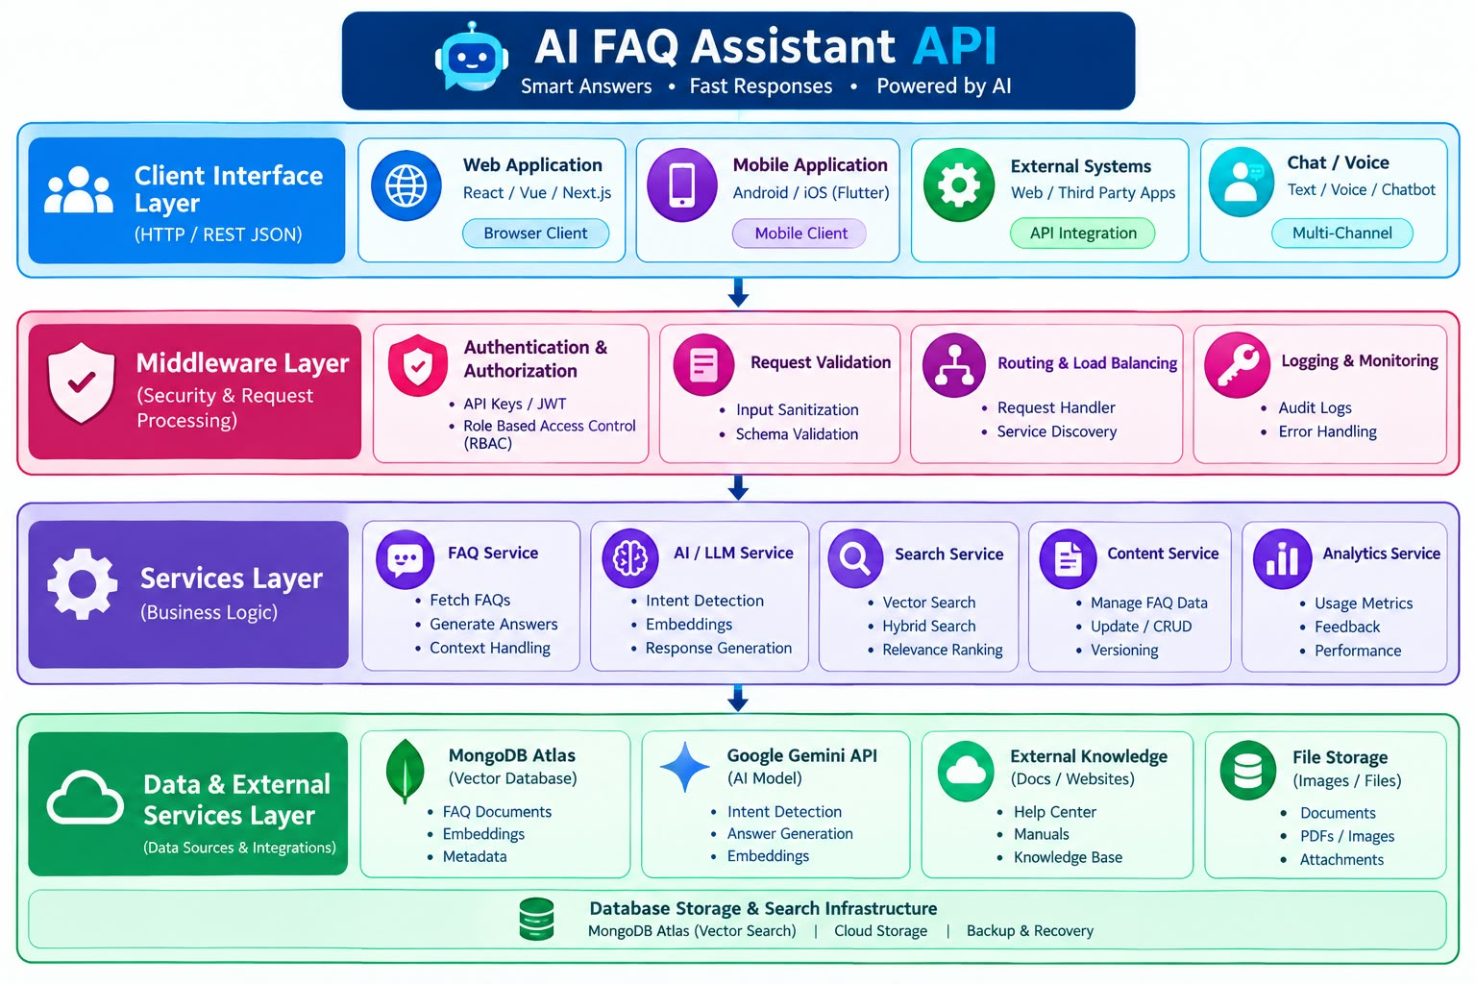
Table 1: Components & Technologies

S.No | Component | Description | Technology
1 | User Interface | API interface through which users and developers interact with the backend | Postman REST API Client
2 | Application Logic-1 | Handles REST API routing, request processing and application flow | Node.js, Express.js
3 | Application Logic-2 | Handles authentication and authorization | JWT, bcryptjs, Express Middleware
4 | Application Logic-3 | Handles AI processing, FAQ generation, question answering and FAQ search operations | Google Gemini API, Search Services
5 | Database | Stores users, FAQs, categories, tags, AI-generated FAQs and feedback data | MongoDB, Mongoose
6 | Cloud Database | Cloud-hosted database for application data | MongoDB Atlas
7 | File Storage | Stores media path/metadata associated with blog content | Database-stored media metadata
8 | External API-1 | Generates AI-assisted FAQ questions, answers and topic suggestions | Google Gemini API
9 | External API-2 | Not used | Not Applicable
10 | Machine Learning Model | Provides AI-based processing for FAQ generation and question answering | Google Gemini AI Model
11 | Infrastructure (Server / Cloud) | Backend runs locally while database and AI services are cloud-based | Local Node.js Server + MongoDB Atlas + Google Gemini Cloud

The BlogNest project specifically uses Node.js, Express.js, MongoDB/Mongoose, Postman, and Google Gemini, while the common template asks the technology architecture to identify storage, external APIs, and machine-learning interfaces.

Table 2: Application Characteristics

S.No | Characteristics | Description | Technology
1 | Open-Source Frameworks | Backend development uses open-source runtime, framework and database technologies | Node.js, Express.js, Mongoose
2 | Security Implementations | Protects user accounts and APIs using authentication, authorization, password hashing, validation, sanitization and rate limiting | JWT, bcryptjs, RBAC, Input Validation, Express Middleware
3 | Scalable Architecture | Modular backend architecture separates routes, controllers, business logic and database operations, allowing additional FAQ and AI features to be added independently | MVC, Express.js, Service Layer, MongoDB
4 | Availability | Database and external AI services can be accessed whenever the backend and required cloud services are available | MongoDB Atlas, Google Gemini API
5 | Performance | Uses efficient database queries, structured API operations, filtering and search mechanisms to process FAQ information efficiently | Mongoose, MongoDB Queries, FAQ Search

Technology Stack Summary

Backend
Node.js + Express.js

Database
MongoDB Atlas + Mongoose

Authentication
JWT + bcryptjs

AI
Google Gemini API

FAQ Search

Keyword-based FAQ Search

AI Question Answering
Google Gemini AI

API Testing
Thunder Client
Development Environment
Visual Studio Code

